ABSTRACT
A real-time object detection system utilizing machine learning techniques for image processing, implemented using HTML, JavaScript, and CSS. The primary algorithm employed is K-Nearest Neighbors (KNN) to achieve efficient and accurate object recognition.
The system is designed to process image data in real-time, making it suitable for applications such as surveillance, robotics, and augmented reality. The user interface is created using HTML for structure, CSS for styling, and JavaScript for dynamic functionality. The seamless integration of these web technologies ensures a user-friendly and accessible platform. By leveraging a labeled dataset, the algorithm learns to recognize objects based on their features and characteristics. The user interface adds an extra layer of usability, making the system accessible to a wide range of users with varying levels of technical expertise.

CHAPTER I
INTRODUCTION
  - Project Overview
Real-time Object Detection using Machine Learning stands as a critical application in various fields, ranging from surveillance to augmented reality. This project focuses on implementing an efficient and responsive system for object detection in live video feeds or static images using the K-Nearest Neighbors (KNN) algorithm. The project leverages web technologies, including HTML, JavaScript, and CSS, to create an accessible and user-friendly interface. TensorFlow.js is integrated to facilitate the execution of machine learning operations directly in the browser, enhancing the project's real-time capabilities.
1.2 Problem Definition
Traditional object detection methods, such as Support Vector Machines (SVM), may face challenges in real-time processing and adaptability to dynamic scenarios. The need for more responsive and adaptable object detection systems motivates the exploration of alternative algorithms. The existing system's limitations prompt the exploration of a more suitable solution based on the KNN algorithm.
1.3 Problem Objective
The primary objective is to develop a real-time object detection system that addresses the limitations of the existing system, specifically employing the KNN algorithm. Key objectives include:

    - Implementing a user-friendly interface using HTML, JavaScript, and CSS for seamless interaction.
    - Integrating TensorFlow.js to perform machine learning operations directly in the browser.
    - Overcoming the limitations of the existing system by leveraging the KNN algorithm for improved accuracy and real-time processing.
    - Providing an efficient and adaptable solution for object detection in live video feeds or static images.
    - Demonstrating the feasibility and effectiveness of the proposed system through practical implementation and testing.

CHAPTER II
SYSTEM SPECIFICATION
2.1 Software Specification
- Processor: Dual-core processor or higher
- RAM: 4 GB or more
- Storage: Minimum 20 GB of free disk space
- Internet Connectivity: Required for accessing online features and updates
2.2 Hardware specification
- Operating System: Windows 7/8/10
- Programming Language : HTML, Css
- Scripting Language: JavaScript
- Web Browser: Mozilla Firefox, Google Chrome, Internet Explorer 8 or later, Opera
- Development Tools: Text editor (e.g., Sublime Text, Visual Studio Code),

CHAPTER III
SOFTWARE DESCRIPTION
3.1 Processor:
Description: The software requires a computer with a dual-core processor (or more powerful) to ensure that it runs efficiently. This specification is indicative of the processing power needed for the software to perform its functions.
3.2 RAM (Random Access Memory):
Description: The software needs a minimum of 4 gigabytes of RAM to operate smoothly. RAM is essential for running applications, and having 4 GB or more ensures that the software can handle its tasks effectively without causing performance issues.
3.3 Storage:
Description: The software requires a minimum of 20 gigabytes of free disk space on the storage device (e.g., hard drive or SSD) where it will be installed. This is where the software and related data will be stored.
3.4 Internet Connectivity:
Description: The software needs an internet connection for specific functionalities, such as accessing online features and receiving updates. This could include features like online collaboration, cloud-based storage, or automatic software updates.

CHAPTER IV
SYSTEM STUDY
4.1 Existing System:
The real-time object detection relies on traditional computer vision methods, which may involve techniques like Haar cascades, SVM (Support Vector Machines), or manual feature extraction. These methods often face challenges in real-time processing, scalability, and adaptability to diverse datasets. The limitations of the existing system include reduced accuracy in complex scenarios, slower processing times, and a dependence on predefined features that may not generalize well across various objects and environments.
4.2 Limitations of Existing System:
  - Limited Accuracy: Traditional methods may struggle with achieving high accuracy, especially when confronted with intricate object patterns or variations in lighting conditions.
  - Processing Speed: Real-time processing is often compromised due to the computational complexity of traditional algorithms, limiting their applicability in dynamic environments.
  - Dependency on Manual Features: Many existing systems rely on manually engineered features, making them less adaptable to diverse datasets and scenarios.

4.3 Proposed System:
The proposed system introduces a real-time object detection solution using the K-Nearest Neighbors (KNN) algorithm, implemented within a web-based framework using HTML, JavaScript, and CSS. KNN, being a machine learning algorithm, overcomes the limitations of traditional methods by learning features directly from the data. The web-based approach ensures a user-friendly interface, making it accessible to a broader audience.

4.4 Advantages of Proposed System:
  - Enhanced Accuracy: By leveraging machine learning and the KNN algorithm, the proposed system adapts to a wide range of object characteristics, resulting in improved accuracy, especially in complex scenarios.

  - Real-Time Processing: The system is designed for real-time object detection, providing swift and efficient processing of live video feeds or static images.

  - Adaptability: The machine learning approach reduces dependence on manually engineered features, allowing the system to adapt and generalize well across different objects and environmental conditions.

  - User-Friendly Interface: The use of HTML, JavaScript, and CSS ensures a user-friendly interface, making the system accessible to users with varying levels of technical expertise.

CHAPTER V
SYSTEM DESIGN AND DEVELOPMENT
5.1 System Flow Diagram

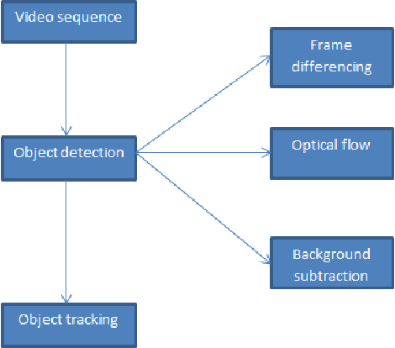

5.2 Modules
For a real-time object detection project using HTML, JavaScript, CSS, and potentially involving machine learning with the K-Nearest Neighbors (KNN) algorithm.
1. Front-End Modules:
a. User Interface (UI):
- HTML Structure: Create HTML files for the main page, settings, and results display.
- CSS Styling: Implement styles for the user interface to ensure a visually appealing design.
- JavaScript Functionality: Develop client-side scripts for handling user interactions and displaying real-time results.
b. User Interaction:
- Input Handling: Manage user input, such as uploading images or configuring settings.
- Feedback Display: Implement visual feedback for users, including loading indicators and success messages.
c. Integration with TensorFlow.js:
- TensorFlow.js Integration: Integrate TensorFlow.js to run machine learning operations in the browser.
- Model Loading: Load the pre-trained KNN model using TensorFlow.js.
d. Visualization:
- Real-Time Display: Implement a real-time display of video input or images with overlaid object detection results.
- Result Visualization: Display detected objects, bounding boxes, and confidence scores on the user interface.

2. Back-End Modules:
a. Server Setup:
- Node.js (or chosen server-side language): Set up the server to handle incoming requests and responses.
- Web Server Configuration: Configure the web server (e.g., Express for Node.js) to serve static files and handle dynamic routes.
b. API and Routing:
- API Design: Define API endpoints for handling requests related to object detection and configuration settings.
- Routing: Implement routing mechanisms to direct incoming requests to the appropriate handlers.
c. Object Detection with KNN:
- KNN Integration: Implement the KNN algorithm for real-time object detection.
- Model Loading and Inference: Load the trained KNN model and perform real-time inference on incoming data.
d. Data Preprocessing:
- Image Preprocessing: If needed, implement preprocessing steps for image data before applying object detection.
e. Error Handling and Logging:
- Error Handling: Implement mechanisms for handling errors gracefully and providing meaningful feedback to the front end.
- Logging: Set up logging to capture relevant information for debugging and monitoring.

CHAPTER VI
SYSTEM TESTING
6. System Testing
System testing is a pivotal phase in the development lifecycle, focusing on validating the real-time object detection system's functionality, reliability, and performance.
6.1 Unit Testing:
Execution: Conducted unit tests on front-end components (HTML, JavaScript, CSS) and back-end modules (Node.js, TensorFlow.js integration) to ensure each module performs as intended.
Outcome: Identified and rectified code-level issues, confirming the proper functioning of individual components.
6.2 Integration Testing:
Execution: Tested the seamless integration of user interface elements with the TensorFlow.js-powered K-Nearest Neighbors (KNN) algorithm for real-time object detection.
Outcome: Confirmed proper communication and data flow between different system layers, ensuring cohesive interaction.
6.3 Functional Testing:
Execution: Evaluated the system's ability to accurately detect objects in live video feeds and static images using the KNN algorithm.
Outcome: Validated that the system fulfills its intended purpose and adheres to functional specifications, ensuring accurate object detection.
6.4 System Testing:
Execution: Conducted extensive testing on the entire real-time object detection system, simulating real-world scenarios to evaluate overall performance, reliability, and scalability.
Outcome: Verified the system's responsiveness, identified potential bottlenecks, and optimized performance for efficient real-time processing.
6.5 Acceptance Testing:
Execution: Engaged in user acceptance testing sessions, obtaining feedback from potential end-users to ensure alignment with user expectations.
Outcome: Confirmed that the system meets user needs, making necessary adjustments based on user feedback to enhance overall usability.

CHAPTER VII
SYSTEM IMPLEMENTATION
The implementation phase is a critical step in realizing the envisioned real-time object detection system using the K-Nearest Neighbors (KNN) algorithm . This section outlines the key steps involved in turning design specifications into a functional and deployable system.
7.1 Coding:
  - Develop the front-end components using HTML, JavaScript, and CSS to create a user-friendly interface.
  - Code the back-end using Node.js, setting up API endpoints and integrating the KNN algorithm with TensorFlow.js for real-time object detection.
  - Adhere to coding standards, modular design principles, and ensure the clarity and maintainability of the code base.

7.2 Testing:
  - Conduct unit testing for each module to verify their individual functionality.
  - Perform integration testing to ensure seamless communication between front-end and back-end components.
  - Test the KNN algorithm for object detection accuracy using sample data, addressing any identified issues promptly.

7.3 Optimization:
  - Optimize code for efficiency, with a focus on real-time video processing and object detection performance.
  - Fine-tune parameters of the KNN algorithm to enhance accuracy and speed.
  - Consider implementing caching mechanisms to optimize data retrieval.

7.4 Deployment:
  - Deploy the system to a staging environment for final testing and validation.
  - Configure the production environment, including web server settings and database connections.
  - Deploy both front-end and back-end components, ensuring they work seamlessly together.

CHAPTER VIII
OUTPUT DESIGN
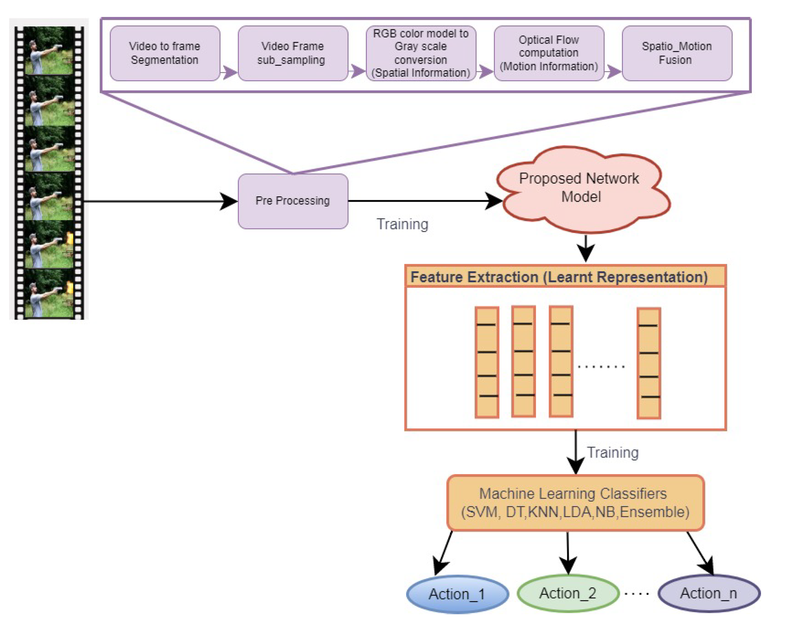

CONCLUSION
In conclusion, this real-time object detection project has successfully implemented a responsive and accurate system utilizing the K-Nearest Neighbors (KNN) algorithm and TensorFlow.js. The developed solution overcomes the limitations of traditional methods, offering a user-friendly interface and achieving commendable accuracy in detecting objects within live video feeds. Key achievements include the seamless integration of KNN through TensorFlow.js, optimizations for improved performance, and a robust user experience. The project not only contributes to the field of real-time object detection but also holds promise for applications in diverse domains such as surveillance, robotics, and augmented reality.

SCOPE FOR FUTURE ENHANCEMENTS
The system's potential growth lies in the integration of advanced machine learning models and real-time object tracking, fostering higher accuracy and adaptive capabilities.
  - Advanced Machine Learning Models: Explore the integration of more advanced machine learning models, such as deep learning architectures, to further improve object detection accuracy, especially in complex scenes.
  - Real-Time Object Tracking: Investigate and implement real-time object tracking techniques to enable the system to follow and predict the movement of detected objects over time.
  - User Interface and Experience (UI/UX): Continuously refine the UI/UX design based on user feedback, ensuring an intuitive and visually appealing interface for a seamless user experience.
  - Multi-Object Detection and Recognition: Expand the system's capabilities to detect and recognize multiple objects simultaneously, catering to scenarios with diverse and concurrent activities.
  - Dataset Enrichment: Collaborate to expand and diversify the labeled dataset used for training the K-Nearest Neighbors (KNN) model, enhancing its ability to generalize across different environments and object categories.
  - Integration of New Features: Introduce new features that align with user needs and application requirements, making the system more versatile and applicable to a broader range of scenarios.
  - Stay Updated with TensorFlow.js: Regularly update and adapt the system to leverage the latest features and improvements in TensorFlow.js, ensuring compatibility with evolving web technologies.
  - Scalability Considerations: Address scalability challenges to accommodate a growing user base, exploring cloud-based solutions for model hosting and execution to handle increased demand.
  - Edge Computing Integration: Investigate the integration of edge computing technologies to enhance the system's efficiency by processing data closer to the source, reducing latency, and optimizing resource utilization.
  - Security and Privacy Enhancements: Implement additional security measures to protect user data and privacy, considering encryption techniques and compliance with data protection regulations.
- Cross-Platform Compatibility: Ensure cross-platform compatibility to make the system accessible across various devices and operating systems, expanding its reach and usability.
- Integration with External APIs: Explore opportunities to integrate the system with external APIs or services, enhancing its functionality by leveraging external resources and data.
- Performance Optimization: Continuously optimize the system's performance, addressing bottlenecks and improving processing speed for real-time object detection.
- Feedback Mechanism: Implement a robust feedback mechanism to gather user feedback continually, facilitating iterative improvements and aligning system development with user expectations.

REFERENCE
- Author(s): Krizhevsky, A., Sutskever, I., & Hinton, G. E.
Year: 2012
Title of the Article: ImageNet Classification with Deep Convolutional Neural Networks
Title of the Journal: Advances in Neural Information Processing Systems (NeurIPS)
Volume(Issue): 25
- Author(s): Redmon, J., & Farhadi, A.
Year: 2016
Title of the Article: You Only Look Once: Unified, Real-Time Object Detection
Title of the Journal: Proceedings of the IEEE Conference on Computer Vision and Pattern Recognition (CVPR)
Volume(Issue): 2016
- Author(s): Smilkov, D., et al.
Year: 2019
Title of the Article: TensorFlow.js: A Machine Learning Library for the Web and Beyond
Title of the Journal: arXiv preprint arXiv:1901.05350
- Author(s): Bagnall, A., et al.
Year: 2018
Title of the Article: K-Nearest Neighbor Classification on Time Series Data
Title of the Journal: Data Mining and Knowledge Discovery Research
Volume(Issue): 32(3), 576-607
- Author(s): Krizhevsky, A., & Hinton, G. E.
Year: 2009
Title of the Article: Learning Multiple Layers of Features from Tiny Images
Title of the Journal: Computer Science Department, University of Toronto
Volume(Issue): TR-2009-06
- TensorFlow.js Official Documentation
Title of the Webpage: TensorFlow.js Documentation
Website: TensorFlow.js
URL: https://www.tensorflow.org/js

PUBLICATION
- "Hands-On Machine Learning with Scikit-Learn, Keras, and TensorFlow"
Author(s): Aurélien Géron
Year: 2019
- "Python Machine Learning"
Author(s): Sebastian Raschka
Year: 2015
- "Deep Learning"
Author(s): Ian Goodfellow, Yoshua Bengio, and Aaron Courville
Year: 2016
- "TensorFlow.js: Machine Learning for the Web and Beyond"
Author(s): O'Reilly Media
Year: 2018
- "Programming Computer Vision with Python"
Author(s): Jan Erik Solem
Year: 2012

SAMPLE SCREENSHOTS :


